Lab 1 Evaluations

==================

1.Extract data files from Customer data like USA country one file France country one file and UK country one file



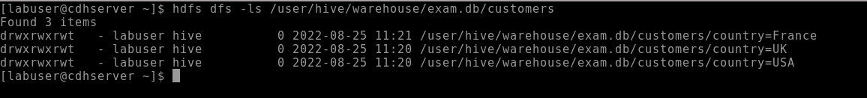

2.Extract datas from other files order / orderdetails / Payment only for Correspoding countries above mentioned (USA,UK,France customers datas only)

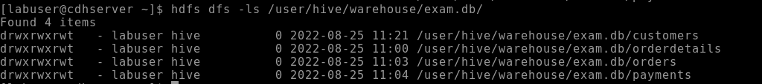

(Now 6 files should ready (USA,UK,France, files from customer files) Order, Orderdetails, payments(for only customers belongs to USA,UK,France))

3.Put all files into Local/NAS area using Hadoop commands and move to Hive tables as specified below.



4.create payment table as external table.



5.Create Manage tables for customer table by using country column as partition (usa/uk/France datas)



6.create manage tables using order and oderdetails tables (data should belong to USA,UK,France)



7.Write query to find total payment done for France customers..





8.Write a query to find total orders made by each countrywise..

